Practice Guideline
The American College of Obstetricians and Gynecologists recommends recognizing catamenial seizures as cyclic seizure exacerbation in relation to the menstrual cycle, defined as a twofold increase in baseline average daily seizure activity during a particular phase of the menstrual cycle.[1] Diagnosis requires evaluation of a menstrual and seizure diary.[1]
Catamenial Patterns and Timing
More than one third of postmenarchal girls and women with medication-refractory epilepsy experience catamenial seizure exacerbation.[1] The most common seizure pattern is perimenstrual, occurring 3 days before menses and the first 3 days of menses, when progesterone levels drop in ovulatory cycles.[1] Periovulatory catamenial exacerbation has been attributed to the midcycle surge of estrogen that is relatively unopposed by progesterone.[1] Patients have fewest seizures during the midluteal phase in ovulatory cycles when progesterone levels are highest.[1]
The menstrual cycle variation in steroid hormone levels and ratios correlates with the timing of seizures in catamenial epilepsy.[1]
Catamenial Visceral Seizures: Clinical Context
While the term "catamenial visceral seizure" is not a standard classification in the medical literature, it likely refers to seizures with visceral or autonomic features (such as epigastric rising sensation, nausea, abdominal discomfort, or other autonomic symptoms) that occur in a catamenial pattern. These visceral symptoms can be part of focal seizures, particularly those originating from the temporal lobe or insular cortex.[2]
Pathophysiology
Catamenial epilepsy affects approximately 40% of women with epilepsy and is driven by hormonal fluctuations.[2] Three distinct patterns have been identified:[2][3]
- C1 (perimenstrual): Days -3 to +3 around menstruation, related to progesterone withdrawal
- C2 (periovulatory): Around ovulation (day 14), related to estrogen surge
- C3 (luteal phase): Days 10 through day 3 of next cycle in anovulatory cycles with inadequate luteal phase
The mechanisms involve premenstrual withdrawal of anticonvulsant neurosteroids (particularly allopregnanolone, a progesterone metabolite), alterations in GABA-A receptor subunits, and the neuroexcitatory effects of estrogen.[4][3]
Treatment Approaches
Treatment depends on whether menses are regular or irregular:[2][5]
For regular menses:
- Clobazam: 20-30 mg nightly for 10 days starting 2 days before expected seizures (78% response rate in one study)[5][3]
- Natural progesterone: 200 mg three times daily on days 14-25 for women with ≥3-fold increase in perimenstrual seizures (37.8% responders vs 11.1% with placebo in severely affected women)[5][3]
- Acetazolamide: 250-500 mg daily from 3-7 days prior to menses[2][3]
- Dose adjustment: Temporary increase in baseline antiepileptic drugs during vulnerable periods[3]
For irregular menses:
- Oral contraceptives to regulate cycles and make seizures more predictable[5][3]
- Medroxyprogesterone acetate (Depo-Provera) or GnRH analogues for menstrual suppression in severe, refractory cases[2][3]
Diagnostic Approach
When catamenial epilepsy is suspected, maintain a seizure and menstrual diary for at least 3 menstrual cycles to establish the pattern and relationship to menstrual phases.[5][3] This documentation is essential for determining the appropriate treatment timing and approach.
Would you like to explore the specific diagnostic workup for distinguishing visceral seizures from other causes of cyclic autonomic symptoms in women of reproductive age?
References
- Gynecologic Management of Adolescents and Young Women With Seizure Disorders: ACOG Committee Opinion, Number 806. Committee on Adolescent Health Care. Obstetrics and Gynecology. 2020;135(5):e213-e220. doi:10.1097/AOG.0000000000003827.
- Treatments for Seizures in Catamenial (Menstrual-Related) Epilepsy. Maguire MJ, Nevitt SJ. The Cochrane Database of Systematic Reviews. 2021;9:CD013225. doi:10.1002/14651858.CD013225.pub3.
- Neuroendocrine Considerations in the Treatment of Men and Women With Epilepsy. Harden CL, Pennell PB. The Lancet. Neurology. 2013;12(1):72-83. doi:10.1016/S1474-4422(12)70239-9.
- Interneurons, Gabaa Signaling and Their Presumptive Role in Catamenial Epilepsy. Li FR, Wang S, Suarez CF, Lévesque M, Avoli M. Neuroscience and Biobehavioral Reviews. 2025;:106291. doi:10.1016/j.neubiorev.2025.106291.
- Management of Epilepsy in Women. Stephen LJ, Harden C, Tomson T, Brodie MJ. The Lancet. Neurology. 2019;18(5):481-491. doi:10.1016/S1474-4422(18)30495-2.
This critical new information—that all episodes occur on menstrual days 1-2—substantially changes the differential diagnosis. This pattern strongly suggests catamenial vasovagal syncope (menstruation-triggered reflex syncope) rather than catamenial epilepsy, though both remain in the differential.
Most Likely Diagnosis
Catamenial vasovagal syncope (menstruation-triggered reflex syncope)
The presentation combines classic features of vasovagal syncope with a striking menstrual pattern:[1][2][3]
- Stereotyped prodrome: Abdominal pain → diarrhea → syncope within 3 minutes is the classic autonomic prodrome of vasovagal syncope[4][5][3]
- Rapid recovery: Complete recovery in 1-2 hours without prolonged confusion strongly favors syncope over seizures (seizures typically cause >30 minutes of postictal confusion)[6][5]
- Situational triggers: Morning occurrence after long rides suggests dehydration/volume depletion as a predisposing factor[7][3][4]
- Menstrual timing: Both vasovagal syncope patients and healthy women report greatest lightheadedness during menses, with severity scores of 53-56 during menstruation versus 41-44 during the follicular phase[2]
The consistent occurrence on days 1-2 of menses likely reflects the convergence of multiple physiologic stressors: hormonal changes (progesterone withdrawal), menstrual-related GI symptoms (prostaglandin-mediated cramping and diarrhea), and volume depletion from both menstruation and post-travel dehydration.[2][8][3]
Other Diagnoses to Consider
Catamenial visceral (autonomic) epilepsy
While less likely given the rapid recovery, this cannot be excluded without EEG documentation:[1][9]
- Catamenial epilepsy affects ~40% of women with epilepsy, with perimenstrual pattern (days -3 to +3) being most common[1][10]
- Visceral/autonomic auras (epigastric sensation, nausea, abdominal discomfort) can occur with focal seizures, particularly temporal lobe origin
- However, the rapid recovery without postictal confusion argues strongly against this diagnosis[6][5]
Cardiac arrhythmia
Cannot be definitively excluded without cardiac monitoring during an event, though the prodrome makes this less likely.[4][5]
Primary dysmenorrhea with exaggerated vasovagal response
Severe menstrual cramping can trigger vasovagal syncope through pain and prostaglandin-mediated effects.[7][3]
Diagnostic Approach
Key distinguishing features between syncope and seizures:[6][5]
Feature | Vasovagal Syncope | Focal Seizure
Prodrome | Nausea, warmth, pallor, diaphoresis, abdominal discomfort (common) | Aura may be stereotyped but distinct (déjà vu, epigastric rising)
Duration of LOC | 1 minute | Variable, often >1 minute
Post-event confusion | Rapid recovery, fatigue common | Prolonged (>30 min) postictal confusion
Movements during event | Brief (10), asymmetric jerks if present | More sustained, stereotyped movements
Triggers | Situational (standing, pain, emotion, medical settings) | May lack clear trigger or have specific auras
References | [1], [2], [3] | [2], [3], [4]
Recommended evaluation:
History refinement:
- Detailed witness account of the 6 episodes to assess for seizure features (sustained tonic-clonic activity, lateral tongue biting, prolonged confusion)[6][11]
- Menstrual diary for 3 cycles documenting exact timing of symptoms relative to cycle[1]
- Hydration status and fluid intake before long rides
- Medication review (especially NSAIDs, which can worsen GI symptoms)
Initial testing:
- 12-lead ECG if not already done to exclude long QT, Brugada pattern, or other arrhythmogenic substrate[4][12]
- Orthostatic vital signs (supine, 1 min, 3 min standing) to assess for orthostatic hypotension[4]
- Hemoglobin to assess for anemia from menstrual blood loss[4]
Diagnostic testing to distinguish syncope from seizure:
Given the infrequent nature (6 episodes in 3 years, all during menses), the following approach is recommended:
- Tilt-table testing with simultaneous EEG monitoring is reasonable to distinguish convulsive syncope from epilepsy (Class IIa recommendation). During tilt-induced syncope, EEG shows diffuse slowing with delta waves and flat-line pattern, whereas epileptic seizures show epileptiform discharges[12][7]
- Ambulatory cardiac monitoring is challenging given the predictable monthly timing. An external loop recorder or patch monitor could be worn during days 1-3 of menses for 2-3 cycles to capture events[12]
- Routine EEG is NOT recommended for syncope evaluation unless seizure features are present (Class III: No Benefit). However, if seizure remains a concern after history review, interictal EEG may show epileptiform discharges supporting epilepsy diagnosis[12][7][11]
- Video-EEG monitoring would be definitive if an episode could be captured, but given the infrequent and predictable timing, this is impractical unless episodes become more frequent[11]
Red flags requiring urgent evaluation:
- Syncope during exertion (suggests cardiac cause)[4]
- Family history of sudden cardiac death
- Abnormal ECG findings
- Prolonged post-event confusion (>30 minutes suggests seizure)[6][13]
Management Considerations
If vasovagal syncope is confirmed:[7][4]
- Patient education about diagnosis, triggers, and benign prognosis (Class I recommendation)[7]
- Preventive strategies for menstrual days 1-3:
- Aggressive hydration (2-3L fluid, increased salt intake) starting 24-48 hours before menses[7][4]
- Avoid prolonged standing, hot environments
- Physical counter-pressure maneuvers if prodrome occurs (leg crossing, squatting)[7]
- Pharmacologic options if conservative measures fail:
- Midodrine 5-10 mg taken on mornings of days 1-3 of menses (Class IIa for recurrent VVS)[7][4]
- Fludrocortisone 0.1 mg daily during vulnerable days (Class IIb)[7][4]
- NSAIDs for dysmenorrhea may help reduce GI symptoms but should be used cautiously
If catamenial epilepsy is diagnosed:[10][9]
- Clobazam 20-30 mg nightly for 10 days starting 2 days before expected symptoms (78% response rate)[9]
- Acetazolamide 250-500 mg daily from 3-7 days prior to menses[10]
- Natural progesterone 200 mg TID on days 14-25 for women with ≥3-fold perimenstrual increase (37.8% responders in severely affected women)[9]
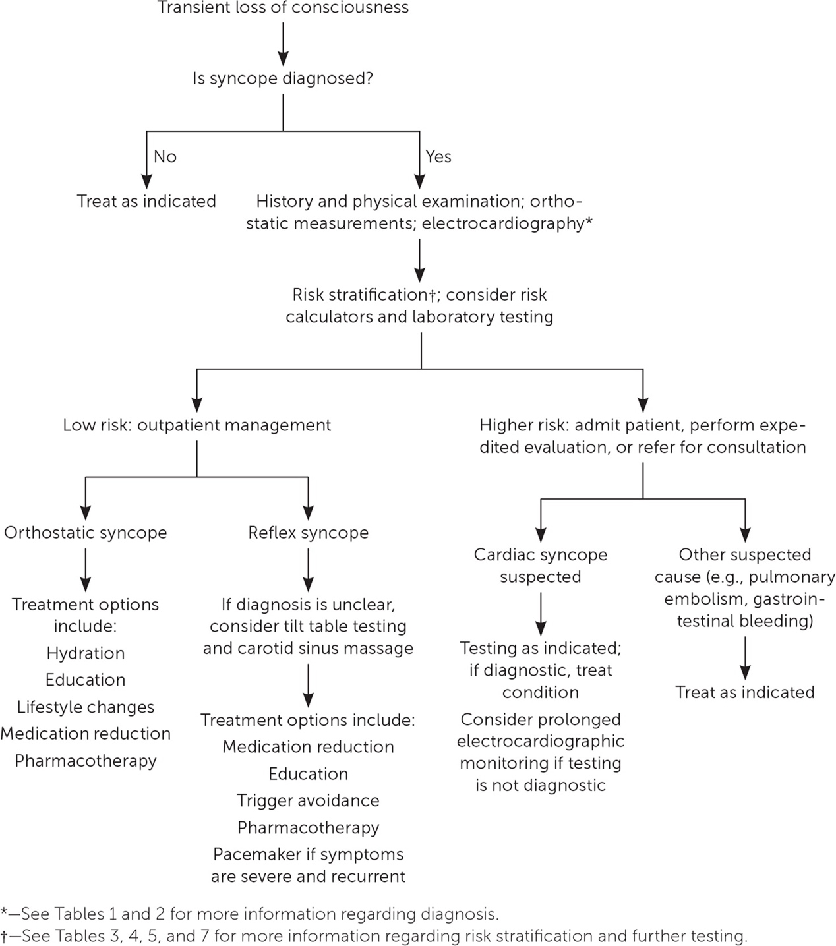Figure 1 Evaluation of syncope. Information from references 1, 5, 8, and 12. undefined
The evaluation algorithm above illustrates the systematic approach to syncope evaluation, emphasizing that history, physical examination, and ECG form the cornerstone of diagnosis and risk stratification.
Has the patient or any witnesses described the specific characteristics during the loss of consciousness (eye position, color changes, any movements, breathing pattern)? Also, has she had any cardiac evaluation (ECG, echo) or baseline EEG performed?
References
- Gynecologic Management of Adolescents and Young Women With Seizure Disorders: ACOG Committee Opinion, Number 806. Committee on Adolescent Health Care. Obstetrics and Gynecology. 2020;135(5):e213-e220. doi:10.1097/AOG.0000000000003827.
- Gynecological and Menstrual Disorders in Women With Vasovagal Syncope. Muppa P, Sheldon RS, McRae M, et al. Clinical Autonomic Research : Official Journal of the Clinical Autonomic Research Society. 2013;23(3):117-22. doi:10.1007/s10286-013-0190-1.
- Baroreflex Dysfunction. Kaufmann H, Norcliffe-Kaufmann L, Palma JA. The New England Journal of Medicine. 2020;382(2):163-178. doi:10.1056/NEJMra1509723.
- Syncope: Evaluation and Differential Diagnosis. Bayard M, Gerayli F, Holt J. American Family Physician. 2023;108(5):454-463.
- Did This Patient Have Cardiac Syncope?The Rational Clinical Examination Systematic Review. Albassam OT, Redelmeier RJ, Shadowitz S, et al. JAMA. 2019;321(24):2448-2457. doi:10.1001/jama.2019.8001.
- Initial Management of Seizure in Adults. Smith PEM. The New England Journal of Medicine. 2021;385(3):251-263. doi:10.1056/NEJMcp2024526.
- 2017 ACC/AHA/HRS Guideline for the Evaluation and Management of Patients With Syncope: A Report of the American College of Cardiology/American Heart Association Task Force on Clinical Practice Guidelines and the Heart Rhythm Society. Writing Committee Members, Shen WK, Sheldon RS, et al. Heart Rhythm. 2017;14(8):e155-e217. doi:10.1016/j.hrthm.2017.03.004.
- Postural Orthostatic Tachycardia Syndrome: JACC Focus Seminar. Bryarly M, Phillips LT, Fu Q, Vernino S, Levine BD. Journal of the American College of Cardiology. 2019;73(10):1207-1228. doi:10.1016/j.jacc.2018.11.059.
- Management of Epilepsy in Women. Stephen LJ, Harden C, Tomson T, Brodie MJ. The Lancet. Neurology. 2019;18(5):481-491. doi:10.1016/S1474-4422(18)30495-2.
- Treatments for Seizures in Catamenial (Menstrual-Related) Epilepsy. Maguire MJ, Nevitt SJ. The Cochrane Database of Systematic Reviews. 2021;9:CD013225. doi:10.1002/14651858.CD013225.pub3.
- Epilepsy in Adults. Thijs RD, Surges R, O'Brien TJ, Sander JW. Lancet (London, England). 2019;393(10172):689-701. doi:10.1016/S0140-6736(18)32596-0.
- 2017 ACC/AHA/HRS Guideline for the Evaluation and Management of Patients With Syncope: A Report of the American College of Cardiology/American Heart Association Task Force on Clinical Practice Guidelines and the Heart Rhythm Society. Shen WK, Sheldon RS, Benditt DG, et al. Journal of the American College of Cardiology. 2017;70(5):e39-e110. doi:10.1016/j.jacc.2017.03.003.
- Seizure Versus Syncope. McKeon A, Vaughan C, Delanty N. The Lancet. Neurology. 2006;5(2):171-80. doi:10.1016/S1474-4422(06)70350-7.
This autonomic testing result—poor sympathetic modulation and poor sympathetic function with normal parasympathetic function—provides critical diagnostic information that confirms the diagnosis of catamenial vasovagal syncope with underlying sympathetic dysfunction. This pattern is well-documented in patients with recurrent vasovagal syncope and has important therapeutic implications.
Clinical Significance of the Autonomic Testing
The autonomic profile reveals a sympathetic phenotype of vasovagal syncope characterized by:[1][2][3]
Baseline sympathetic dysfunction:
- Increased resting sympathetic activity but blunted sympathetic response to orthostatic stress is characteristic of patients with recurrent vasovagal syncope[2]
- In one study, patients with vasovagal syncope had significantly elevated resting muscle sympathetic nerve activity (42.4 bursts/min vs 26.5 in controls), but activation during orthostatic stress was markedly blunted (5.1 vs 15.2 bursts/min increase at -50 mmHg lower body negative pressure)[2]
- Reduced baroreflex sensitivity is also typical, both at rest and during orthostatic stress[2]
Menstrual cycle effects on sympathetic function:
- During the luteal phase (including days 1-2 of menses), sympathetic activity normally increases in healthy women, but the transduction of sympathetic activity into vascular resistance may be impaired[4]
- Women with premenstrual symptoms show lower plasma norepinephrine during the luteal phase compared to controls (180 vs 320 pg/mL supine, 480 vs 940 pg/mL during tilt), suggesting reduced sympathetic output or increased clearance[5]
- The combination of progesterone withdrawal (which normally suppresses sympathetic outflow) and baseline sympathetic dysfunction creates a "perfect storm" for syncope during early menses[6][7]
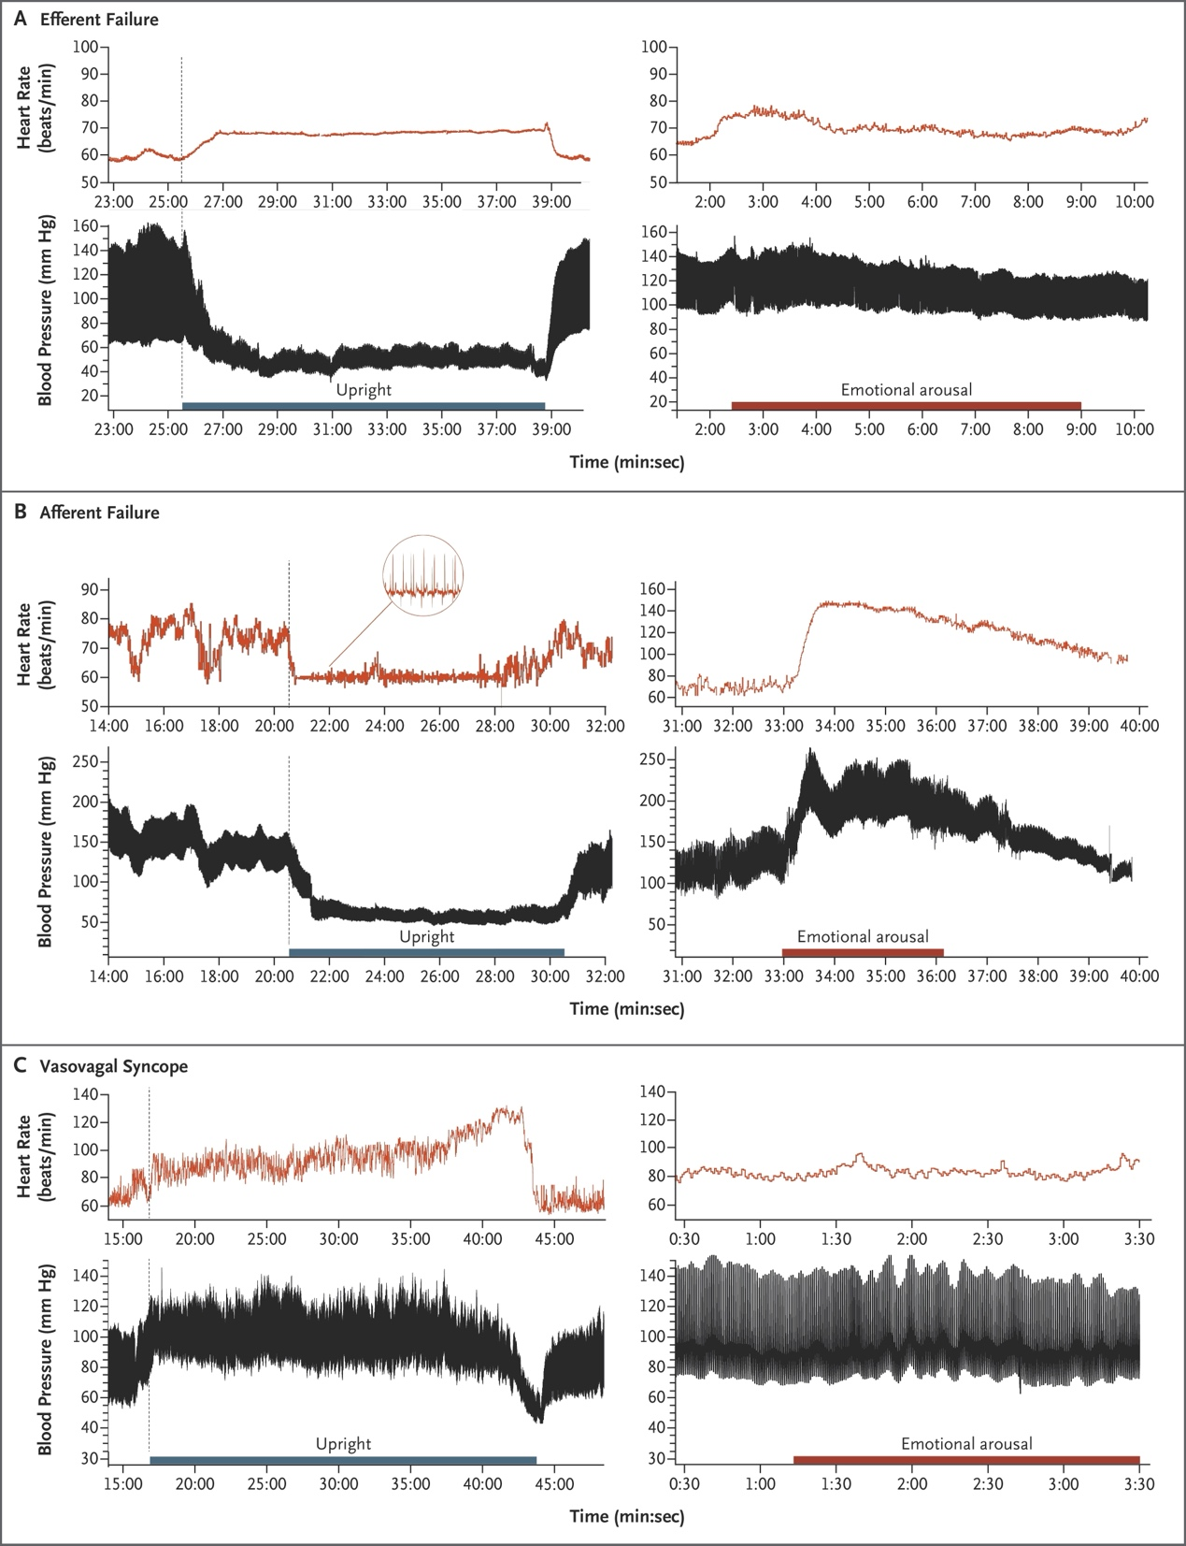Figure 3 Blood Pressure and Heart Rate in Patients with Baroreflex Dysfunction. undefined
The figure above illustrates the characteristic hemodynamic pattern in vasovagal syncope (Panel C), showing initially normal response to upright posture followed by sudden sympathetic withdrawal with precipitous drops in both blood pressure and heart rate.
Pathophysiologic Interpretation
The patient's presentation represents a "low sympathetic reserve" phenotype of vasovagal syncope:[1][3]
1. Baseline sympathetic impairment limits the ability to mount adequate vasoconstriction during orthostatic stress
2. Dehydration from long rides reduces venous return and central blood volume
3. Early menstruation (days 1-2) compounds the problem through:
- Prostaglandin-mediated vasodilation and GI symptoms (cramping, diarrhea)[8]
- Hormonal shifts affecting sympathetic-vascular coupling[5][4]
- Possible volume loss from menstruation itself
4. Morning timing adds orthostatic stress after overnight recumbency
5. The final trigger is abrupt sympathetic withdrawal during defecation, causing the characteristic vasovagal collapse[8][9]
Management Strategy Based on Autonomic Profile
Given the documented sympathetic dysfunction, treatment should focus on augmenting sympathetic vascular toneduring vulnerable periods (menstrual days 1-3 after long rides):[10][11]
First-line interventions (Class I-IIa):
1. Patient education and trigger avoidance (Class I)[10][11]
- Aggressive hydration (2-3L fluid, increased salt) starting 24-48 hours before menses and after long rides[10]
- Avoid prolonged standing, hot environments, and straining during defecation on vulnerable days
- Physical counter-pressure maneuvers if prodrome occurs (leg crossing, squatting)[10][11]
2. Midodrine (Class IIa for recurrent VVS)[10][11]
- Dosing: 5-10 mg taken on mornings of menstrual days 1-3, especially after long rides
- Mechanism: Alpha-1 agonist that directly addresses the sympathetic vasoconstrictor deficit
- Evidence: 43% reduction in syncope recurrence in meta-analysis[10]
- Particularly appropriate given documented poor sympathetic function
- Contraindications: Hypertension, heart failure, urinary retention[10]
Second-line options (Class IIb):
3. Fludrocortisone 0.1 mg daily during vulnerable days (Class IIb)[10][11]
- Increases blood volume through mineralocorticoid activity
- POST II trial showed 31% risk reduction in adults with moderately frequent VVS[10]
- Monitor potassium
4. Increased salt and fluid intake (Class IIb)[10][11]
- Particularly important given the dehydration trigger from long rides
Menstrual-specific considerations:
5. NSAIDs for dysmenorrhea may help reduce prostaglandin-mediated GI symptoms and vasodilation, though use cautiously as they can affect renal sodium handling
6. Hormonal cycle regulation could be considered if episodes remain frequent despite above measures, though this is not specifically addressed in syncope guidelines[12][13]
Not recommended:
- Beta-blockers: Class IIb in patients ≥42 years, but Class III (not indicated) in European guidelines due to negative RCT data[10][14]
- Orthostatic training: Class IIb with uncertain benefit[10][11]
Recommended Next Steps
Immediate management:
1. ECG if not already done to exclude arrhythmogenic substrate[15][11]
2. Hemoglobin to assess for anemia from menstrual blood loss[15]
3. Orthostatic vital signs to document any orthostatic hypotension component[15]
Treatment plan:
Given the documented sympathetic dysfunction and predictable catamenial pattern:
- Start midodrine 5-10 mg on mornings of menstrual days 1-3, particularly after long rides (can titrate dose based on response)
- Implement aggressive hydration protocol: 2-3L fluid with increased salt intake starting 24-48 hours before expected menses
- Educate on physical counter-pressure maneuvers and immediate supine positioning if prodrome occurs
- Consider fludrocortisone 0.1 mg daily if midodrine alone is insufficient
Monitoring:
- Maintain menstrual and syncope diary for 3-6 months to assess treatment response
- Monitor blood pressure and potassium if using fludrocortisone
- Reassess if episodes continue despite treatment
The combination of documented sympathetic dysfunction, catamenial timing, and situational triggers (post-travel dehydration, morning defecation) provides a clear mechanistic understanding and targeted treatment approach for this patient.
Would you like to explore the specific protocols for implementing midodrine therapy in catamenial vasovagal syncope, or discuss alternative approaches if first-line treatments are unsuccessful?
References
- 2015 Heart Rhythm Society Expert Consensus Statement on the Diagnosis and Treatment of Postural Tachycardia Syndrome, Inappropriate Sinus Tachycardia, and Vasovagal Syncope. Sheldon RS, Grubb BP, Olshansky B, et al. Heart Rhythm. 2015;12(6):e41-63. doi:10.1016/j.hrthm.2015.03.029.
- Dysfunctional Baroreflex Regulation of Sympathetic Nerve Activity in Patients With Vasovagal Syncope. Béchir M, Binggeli C, Corti R, et al. Circulation. 2003;107(12):1620-5. doi:10.1161/01.CIR.0000056105.87040.2B.
- Sympathetic Dysfunction in Vasovagal Syncope and the Postural Orthostatic Tachycardia Syndrome. Lambert E, Lambert GW. Frontiers in Physiology. 2014;5:280. doi:10.3389/fphys.2014.00280.
- Influence of the Menstrual Cycle on Sympathetic Activity, Baroreflex Sensitivity, and Vascular Transduction in Young Women. Minson CT, Halliwill JR, Young TM, Joyner MJ. Circulation. 2000;101(8):862-8. doi:10.1161/01.cir.101.8.862.
- Cardiovascular Autonomic Profile in Women With Premenstrual Syndrome. Koifman R, Dayan L, Ablin JN, Jacob G. Frontiers in Physiology. 2018;9:1384. doi:10.3389/fphys.2018.01384.
- Pubertal Hormonal Changes and the Autonomic Nervous System: Potential Role in Pediatric Orthostatic Intolerance. Coupal KE, Heeney ND, Hockin BCD, et al. Frontiers in Neuroscience. 2019;13:1197. doi:10.3389/fnins.2019.01197.
- Menstrual Variation of Autonomic Balance May Be a Factor in Exacerbations of Certain Diseases During the Menstrual Cycle. Lee PY, Bazar KA, Yun AJ. Medical Hypotheses. 2004;63(1):163-7. doi:10.1016/j.mehy.2004.02.036.
- Baroreflex Dysfunction. Kaufmann H, Norcliffe-Kaufmann L, Palma JA. The New England Journal of Medicine. 2020;382(2):163-178. doi:10.1056/NEJMra1509723.
- Vagal and Sympathetic Mechanisms in Patients With Orthostatic Vasovagal Syncope. Morillo CA, Eckberg DL, Ellenbogen KA, et al. Circulation. 1997;96(8):2509-13. doi:10.1161/01.cir.96.8.2509.
- 2017 ACC/AHA/HRS Guideline for the Evaluation and Management of Patients With Syncope: A Report of the American College of Cardiology/American Heart Association Task Force on Clinical Practice Guidelines and the Heart Rhythm Society. Writing Committee Members, Shen WK, Sheldon RS, et al. Heart Rhythm. 2017;14(8):e155-e217. doi:10.1016/j.hrthm.2017.03.004.
- 2017 ACC/AHA/HRS Guideline for the Evaluation and Management of Patients With Syncope: A Report of the American College of Cardiology/American Heart Association Task Force on Clinical Practice Guidelines and the Heart Rhythm Society. Shen WK, Sheldon RS, Benditt DG, et al. Journal of the American College of Cardiology. 2017;70(5):e39-e110. doi:10.1016/j.jacc.2017.03.003.
- Management of Epilepsy in Women. Stephen LJ, Harden C, Tomson T, Brodie MJ. The Lancet. Neurology. 2019;18(5):481-491. doi:10.1016/S1474-4422(18)30495-2.
- Neuroendocrine Considerations in the Treatment of Men and Women With Epilepsy. Harden CL, Pennell PB. The Lancet. Neurology. 2013;12(1):72-83. doi:10.1016/S1474-4422(12)70239-9.
- ACC/AHA/HRS Versus ESC Guidelines For the Diagnosis and Management Of Syncope: JACC Guideline Comparison. Goldberger ZD, Petek BJ, Brignole M, et al. Journal of the American College of Cardiology. 2019;74(19):2410-2423. doi:10.1016/j.jacc.2019.09.012.
- Syncope: Evaluation and Differential Diagnosis. Bayard M, Gerayli F, Holt J. American Family Physician. 2023;108(5):454-463.
The baroreflex arc can be disrupted at three distinct anatomical levels—afferent, central, and efferent—each producing a characteristic clinical phenotype. Vasovagal syncope represents a separate, functional disorder without structural nerve damage. The following figure illustrates the complete baroreflex circuitry and the sites where lesions produce distinct syndromes.
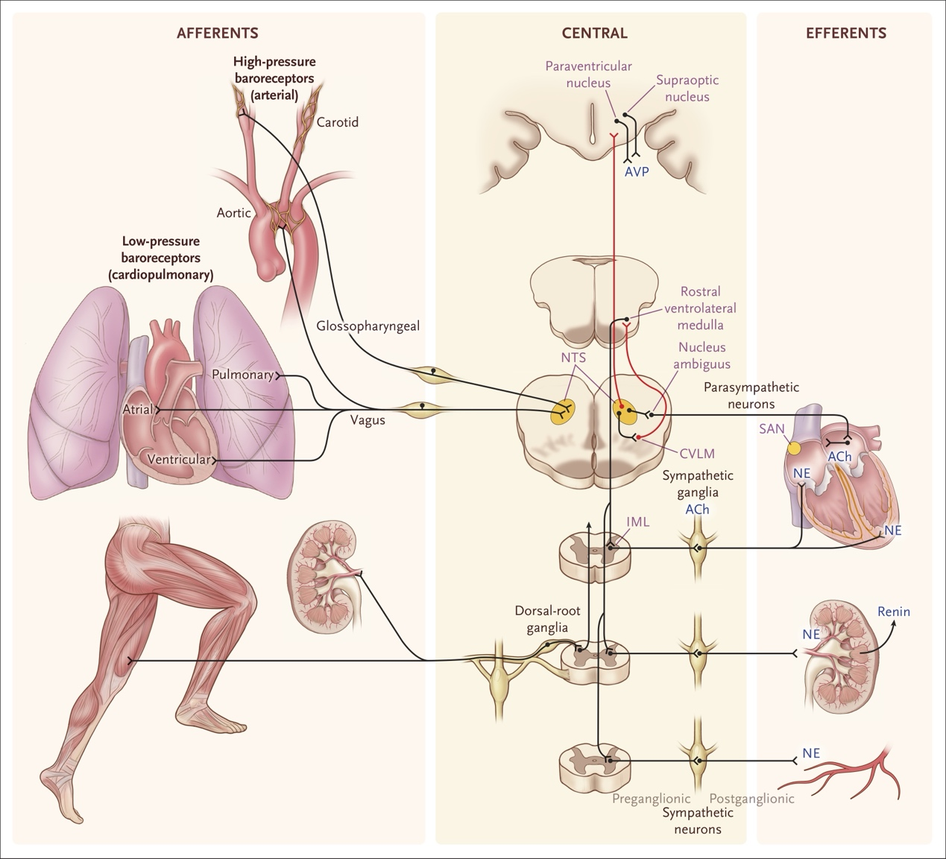Figure 1 Neuroanatomy of Baroreflexes. undefined
---
1. Afferent Baroreflex Failure
Pathophysiology: Loss of sensory input from carotid sinus and aortic arch baroreceptors to the nucleus of the solitary tract (NTS). Without this inhibitory afferent input, cortical signals (e.g., mental stress) reach the rostral ventrolateral medulla (RVLM) unopposed, resulting in unrestrained sympathetic activation with paroxysmal surges in muscle sympathetic nerve traffic, blood pressure, and heart rate.[2][1]
Causes:
- Neck radiation for head/neck cancer (most common, ~86.5% of cases), typically appearing years after treatment due to radiation-induced fibrosis of the carotid sinus[2][3]
- Bilateral carotid body tumor (paraganglioma) resection with damage to the carotid sinus nerve[2][4]
- Familial dysautonomia (hereditary sensory and autonomic neuropathy type 3)[2]
- Rare brainstem lesions involving NTS, Guillain-Barré syndrome, carotid endarterectomy[1]
Clinical features:[2][1][4]
- Labile hypertension with paroxysmal surges (systolic BP up to 280 mmHg) triggered by mental stress, emotional stimuli, or physical activity
- Headache, flushing, diaphoresis, tachycardia, and emotional lability during surges
- Orthostatic hypotension (present in ~75-91% but not universal)
- Plasma norepinephrine is elevated and rises appropriately on standing (intact efferent sympathetic fibers)[5]
Autonomic testing hallmarks:[1][2][4]
- Absent reciprocal heart rate changes during BP fluctuations (no bradycardia with phenylephrine, no tachycardia with nitroprusside)
- Absent heart rate changes during Valsalva maneuver
- Exaggerated pressor response to cold pressor test (distinguishes from efferent failure)[2]
- Normal postganglionic sudomotor function (except focal neck anhidrosis from direct radiation)[5]
Treatment: Clonidine (central sympatholytic) reduced attack frequency by 81% in the original series.[4] Management often requires both antihypertensives and pressor agents.[3]
---
2. Efferent Baroreflex Failure (Autonomic Failure)
Pathophysiology: Damage to the sympathetic efferent neurons—either preganglionic (central) or postganglionic(peripheral)—impairs norepinephrine release at the neurovascular junction, causing insufficient vasoconstriction on standing.[1]
This category is further subdivided:
2a. Central (preganglionic) efferent failure — Multiple System Atrophy (MSA):
- α-Synuclein deposits in oligodendrocytes (glial cytoplasmic inclusions/Papp-Lantos bodies) cause neurodegeneration of central autonomic pathways: RVLM, intermediolateral columns of the spinal cord, dorsal vagal nucleus, and hypothalamus[6][7][8]
- Postganglionic sympathetic neurons are largely spared → plasma norepinephrine is normal or near-normal at rest[9][7]
- Residual sympathetic tone is present but centrally dysregulated[9][10]
2b. Peripheral (postganglionic) efferent failure — Pure Autonomic Failure (PAF) and Parkinson's disease:
- α-Synuclein deposits (Lewy bodies) in postganglionic sympathetic neurons cause peripheral sympathetic denervation[7][1]
- Plasma norepinephrine is very low at rest and fails to rise on standing[9][7]
- Cardiac sympathetic denervation demonstrable on MIBG scintigraphy or 18F-fluorodopamine PET[11][12]
Clinical features common to both subtypes:[2][1]
- Neurogenic orthostatic hypotension (sustained ≥20/10 mmHg drop within 3 minutes of standing)
- Supine hypertension (in ~50%, due to denervation supersensitivity and loss of nocturnal dipping)[1]
- Lightheadedness, visual blurring, syncope, cognitive slowing on standing
- No paroxysmal hypertensive surges triggered by mental stress (distinguishes from afferent failure)[2]
- Blunted heart rate response to orthostatic hypotension (ΔHR/ΔSBP ratio <0.5)[1]
- Additional autonomic deficits: bladder dysfunction, constipation, erectile dysfunction, anhidrosis[13][1]
Autonomic testing hallmarks:[1]
- Reduced or absent BP overshoot after Valsalva maneuver (phase IV)
- Reduced respiratory sinus arrhythmia
- Low plasma norepinephrine (PAF) vs. normal (MSA)
- Absent cold pressor response (unlike the exaggerated response in afferent failure)
The following figure illustrates the pathophysiologic classification of dysautonomias based on the site of sympathetic neurocirculatory failure.
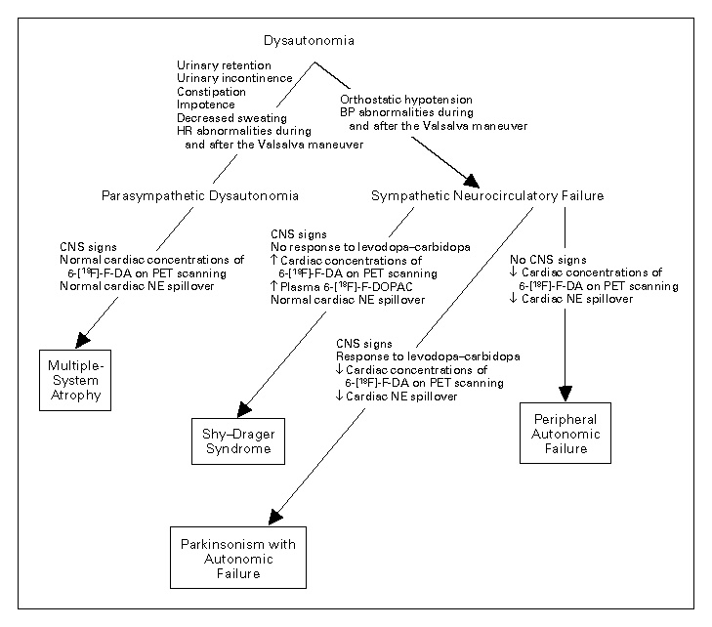Figure 3 Pathophysiologic Classification of Dysautonomias Based on Clinical Physiologic and Laboratory Findings Indicating Sympathetic Neurocirculatory Failure, the Occurrence of Signs of Central Neurodegeneration, and Clinical Responsiveness to Levodopa–Carbidopa. undefined
---
3. Vasovagal Syncope (Functional — No Structural Nerve Disease)
Pathophysiology: Unlike the above structural disorders, vasovagal syncope occurs in patients with intact baroreflex anatomy but an abnormal reflex response. The mechanism involves:[1][14][15]
1. Trigger phase: Orthostatic stress, pain, emotion, or visceral stimuli reduce venous return → decreased cardiac filling
2. Paradoxical response: Vigorous contraction of an underfilled ventricle overstimulates intracardiac mechanoreceptors (Bezold-Jarisch reflex) → paradoxical signal to NTS
3. Sympathetic withdrawal: Abrupt cessation of muscle sympathetic nerve activity (MSNA) → loss of vasoconstriction → precipitous BP drop[1][15]
4. Vagal surge: Simultaneous parasympathetic activation → bradycardia[1]
5. Epinephrine release: Adrenal medullary activation (not under baroreflex control) causes pallor, diaphoresis, nausea during the prodrome[1]
Key distinguishing features from efferent/afferent failure:[1][16][15]
Feature | Afferent Baroreflex Failure | Efferent Baroreflex Failure | Vasovagal Syncope | References
Nerve damage | Afferent (CN IX/X, carotid sinus) | Efferent (pre- or postganglionic sympathetic) | None (functional) | [1], [2]
Sympathetic activity | Unrestrained, excessive | Blunted or absent | Normal at baseline, abrupt withdrawal during event | [1], [2][3]
BP pattern | Labile with paroxysmal surges | Sustained orthostatic hypotension | Normal between events; acute drop during syncope | [1], [2]
Heart rate | Tachycardia during surges, fixed | Blunted HR response (ΔHR/ΔSBP 0.5) | Bradycardia during syncope | [2]
Plasma NE | Elevated | Low (PAF) or normal (MSA) | Normal; fails to rise at time of syncope | [2], [4], [5]
Prodrome | Headache, flushing during surges | Lightheadedness on standing | Pallor, diaphoresis, nausea, warmth | [1], [2], [6]
Recovery | Persistent BP lability | Persistent OH | Rapid, complete | [2], [7]
Triggers | Mental stress, emotion | Postural (standing) | Prolonged standing, pain, emotion, visceral stimuli | [1], [2]
Prognosis | High morbidity/mortality (39.4% over 20 years) | Progressive neurodegeneration | Benign; not a predictor of adverse CV outcomes | [2], [7]
Sympathetic phenotypes in vasovagal syncope:
Recent research has identified distinct sympathetic nervous system phenotypes in patients with recurrent vasovagal syncope:[16]
- Low-pressure phenotype (systolic BP <100 mmHg): Associated with low tyrosine hydroxylase levels → reduced norepinephrine synthesis
- Normal-pressure phenotype (systolic BP >100 mmHg): Associated with increased norepinephrine transporter levels → augmented norepinephrine reuptake
Both phenotypes show below-normal norepinephrine spillover during tilt, which is consistent with the autonomic testing findings in the patient under discussion (poor sympathetic modulation and function with normal parasympathetic parameters).[16]
---
Relevance to the Patient
The patient's autonomic profile—poor sympathetic modulation/function with preserved parasympathetic function—is most consistent with the vasovagal syncope phenotype rather than structural afferent or efferent failure. There is no evidence of the labile hypertension or paroxysmal surges characteristic of afferent failure, nor the persistent neurogenic orthostatic hypotension of efferent failure. The normal SDNN and RRIV confirm intact parasympathetic and overall autonomic architecture, while the sympathetic deficit predisposes to inadequate vasoconstriction during orthostatic and visceral stress—particularly during the vulnerable perimenstrual period.[1][16][15]
Would you like to explore the specific pharmacologic strategies for augmenting sympathetic vascular tone during the perimenstrual period in this patient, including comparative evidence for midodrine versus fludrocortisone?
References
- Baroreflex Dysfunction. Kaufmann H, Norcliffe-Kaufmann L, Palma JA. The New England Journal of Medicine. 2020;382(2):163-178. doi:10.1056/NEJMra1509723.
- Blood Pressure Management in Afferent Baroreflex Failure: JACC Review Topic of the Week. Biaggioni I, Shibao CA, Diedrich A, et al. Journal of the American College of Cardiology. 2019;74(23):2939-2947. doi:10.1016/j.jacc.2019.10.027.
- Natural History of Afferent Baroreflex Failure in Adults. Lamotte G, Coon EA, Suarez MD, et al. Neurology. 2021;97(2):e136-e144. doi:10.1212/WNL.0000000000012149.
- The Diagnosis and Treatment of Baroreflex Failure. Robertson D, Hollister AS, Biaggioni I, et al. The New England Journal of Medicine. 1993;329(20):1449-55. doi:10.1056/NEJM199311113292003.
- Standardized Autonomic Testing in Patients With Probable Radiation-Induced Afferent Baroreflex Failure. Lamotte G, Coon EA, Suarez MD, et al. Hypertension (Dallas, Tex. : 1979). 2022;79(1):50-56. doi:10.1161/HYPERTENSIONAHA.121.17805.
- Autonomic Dysfunction in Multiple System Atrophy: From Pathophysiology to Clinical Manifestations. Luo Y, Yang N, Yang W, et al. Annals of Medicine. 2025;57(1):2488111. doi:10.1080/07853890.2025.2488111.
- Orthostatic Hypotension: JACC State-of-the-Art Review. Freeman R, Abuzinadah AR, Gibbons C, et al. Journal of the American College of Cardiology. 2018;72(11):1294-1309. doi:10.1016/j.jacc.2018.05.079.
- Multiple-System Atrophy. Fanciulli A, Wenning GK. The New England Journal of Medicine. 2015;372(3):249-63. doi:10.1056/NEJMra1311488.
- Multiple System Atrophy: Using Clinical Pharmacology to Reveal Pathophysiology. Jordan J, Shibao C, Biaggioni I. Clinical Autonomic Research : Official Journal of the Clinical Autonomic Research Society. 2015;25(1):53-9. doi:10.1007/s10286-015-0271-4.
- Implanted System for Orthostatic Hypotension in Multiple-System Atrophy. Squair JW, Berney M, Castro Jimenez M, et al. The New England Journal of Medicine. 2022;386(14):1339-1344. doi:10.1056/NEJMoa2112809.
- Sympathetic Cardioneuropathy in Dysautonomias. Goldstein DS, Holmes C, Cannon RO, Eisenhofer G, Kopin IJ. The New England Journal of Medicine. 1997;336(10):696-702. doi:10.1056/NEJM199703063361004.
- Premotor Signs and Symptoms of Multiple System Atrophy. Jecmenica-Lukic M, Poewe W, Tolosa E, Wenning GK. The Lancet. Neurology. 2012;11(4):361-8. doi:10.1016/S1474-4422(12)70022-4.
- The Clinical Approach to Autonomic Failure in Neurological Disorders. Benarroch EE. Nature Reviews. Neurology. 2014;10(7):396-407. doi:10.1038/nrneurol.2014.88.
- Did This Patient Have Cardiac Syncope?The Rational Clinical Examination Systematic Review. Albassam OT, Redelmeier RJ, Shadowitz S, et al. JAMA. 2019;321(24):2448-2457. doi:10.1001/jama.2019.8001.
- Vagal and Sympathetic Mechanisms in Patients With Orthostatic Vasovagal Syncope. Morillo CA, Eckberg DL, Ellenbogen KA, et al. Circulation. 1997;96(8):2509-13. doi:10.1161/01.cir.96.8.2509.
- 2015 Heart Rhythm Society Expert Consensus Statement on the Diagnosis and Treatment of Postural Tachycardia Syndrome, Inappropriate Sinus Tachycardia, and Vasovagal Syncope. Sheldon RS, Grubb BP, Olshansky B, et al. Heart Rhythm. 2015;12(6):e41-63. doi:10.1016/j.hrthm.2015.03.029.
In this case, brain MRA has no diagnostic value, while EEG has limited but conditional value depending on how it is used.
Brain MRA / MRI
The 2017 ACC/AHA/HRS Syncope Guidelines assign a Class III: No Benefit (Level B-NR) recommendation to brain MRI/CT in the routine evaluation of syncope without focal neurological findings.[1][2] This patient has no focal neurological deficits, no headache, no meningismus, and no features suggesting structural intracranial pathology. Syncope results from global cerebral hypoperfusion, not from vascular stenosis or structural brain lesions. Across 5 studies, brain MRI established a diagnosis in only 0.24% of 397 syncope patients, and CT in only 1% of 2,728 patients.[1] A meta-analysis confirmed <1% occurrence of new neurological diagnosis within 30 days of syncope presentation.[3]
Brain MRA specifically evaluates intracranial vascular anatomy (aneurysms, stenosis, AVM). None of these conditions produce the stereotyped catamenial pattern of abdominal pain → diarrhea → syncope with rapid recovery seen in this patient. Vertebrobasilar insufficiency can cause syncope, but would present with focal brainstem signs (diplopia, dysarthria, vertigo, ataxia), which are absent here.[4][5]
EEG
The diagnostic value of EEG depends entirely on the clinical context and how it is deployed:
Routine interictal EEG — low yield (Class III: No Benefit)
A review of 7 studies found routine EEG was ordered in 52% of 2,084 syncope patients but established a diagnosis in only 0.7%.[1] The ACC/AHA/HRS guidelines explicitly state that routine EEG recording is not recommended in syncope evaluation without specific neurological features suggestive of seizure.[1] In this patient, the clinical features (prodrome of abdominal pain/diarrhea, rapid complete recovery without postictal confusion, situational triggers) strongly favor vasovagal syncope over epilepsy.
That said, if a routine EEG were performed and showed epileptiform discharges, this would substantially shift the diagnosis toward catamenial epilepsy. Interictal EEG has a sensitivity of 0.40 and specificity of 0.95 for seizure diagnosis—meaning a positive result nearly doubles the probability of seizure, but a negative result does not exclude it.[6]In patients under 40 years old, the yield of epileptiform abnormalities is higher than in older patients.[7] A sleep-deprived EEG increases yield by an additional 27-30% over a standard recording.[7]
EEG during tilt-table testing — conditionally useful (Class IIa)
The one scenario where EEG provides meaningful diagnostic value is simultaneous EEG and hemodynamic monitoring during tilt-table testing (Class IIa, Level C-LD).[1][2] This approach can definitively distinguish three entities:
- Vasovagal syncope: Diffuse brainwave slowing with delta waves → flat-line pattern (reflecting global hypoperfusion)[1]
- Epileptic seizure: Epileptiform discharges[1]
- Pseudosyncope/psychogenic nonepileptic seizure: Normal EEG throughout the event[1]
However, given that this patient's episodes occur only during menses days 1-2 (6 episodes in 3 years), the likelihood of reproducing an event during tilt-table testing is low.
Summary Recommendation for This Patient
Test | Diagnostic Value | Recommendation | References
Brain MRA | None — no focal neurological findings, no vascular etiology suspected | Not recommended (Class III: No Benefit) | [1], [2]
Routine interictal EEG | Very low yield (0.7%) in syncope; clinical features strongly favor VVS | Not recommended routinely (Class III: No Benefit); consider only if seizure features emerge on detailed history | [1], [3]
Sleep-deprived EEG | Higher yield than routine EEG (+27-30%); reasonable if any residual concern for epilepsy | Optional — could be considered given the catamenial pattern and young age | [4]
EEG + tilt-table testing | Can definitively distinguish syncope vs. epilepsy vs. pseudosyncope if event is captured | Most useful EEG modality (Class IIa) but event capture unlikely given infrequent episodes | [1], [5]
The most cost-effective approach for this patient is to forgo brain MRA entirely and reserve EEG only if detailed witness accounts reveal features concerning for seizure (sustained tonic-clonic activity, lateral tongue biting, prolonged postictal confusion >30 minutes).[7][8] The autonomic testing already obtained (showing sympathetic dysfunction with normal parasympathetic function) provides stronger diagnostic support for vasovagal syncope than either brain MRA or routine EEG would offer.
Would you like to explore whether tilt-table testing with simultaneous EEG monitoring could be strategically timed to the perimenstrual period to maximize the chance of capturing a diagnostic event?
References
- 2017 ACC/AHA/HRS Guideline for the Evaluation and Management of Patients With Syncope: A Report of the American College of Cardiology/American Heart Association Task Force on Clinical Practice Guidelines and the Heart Rhythm Society. Shen WK, Sheldon RS, Benditt DG, et al. Journal of the American College of Cardiology. 2017;70(5):e39-e110. doi:10.1016/j.jacc.2017.03.003.
- 2017 ACC/AHA/HRS Guideline for the Evaluation and Management of Patients With Syncope: A Report of the American College of Cardiology/American Heart Association Task Force on Clinical Practice Guidelines and the Heart Rhythm Society. Writing Committee Members, Shen WK, Sheldon RS, et al. Heart Rhythm. 2017;14(8):e155-e217. doi:10.1016/j.hrthm.2017.03.004.
- ACR Appropriateness Criteria® Syncope. Kligerman SJ, Bykowski J, Hurwitz Koweek LM, et al. Journal of the American College of Radiology : JACR. 2021;18(5S):S229-S238. doi:10.1016/j.jacr.2021.02.021.
- AHA/ACCF Scientific Statement on the Evaluation of Syncope: From the American Heart Association Councils on Clinical Cardiology, Cardiovascular Nursing, Cardiovascular Disease in the Young, and Stroke, and the Quality of Care and Outcomes Research Interdisciplinary Working Group; And the American College of Cardiology Foundation: In Collaboration With the Heart Rhythm Society: Endorsed by the American Autonomic Society. Strickberger SA, Benson DW, Biaggioni I, et al. Circulation. 2006;113(2):316-27. doi:10.1161/CIRCULATIONAHA.105.170274.
- AHA/ACCF Scientific Statement on the Evaluation of Syncope: From the American Heart Association Councils on Clinical Cardiology, Cardiovascular Nursing, Cardiovascular Disease in the Young, and Stroke, and the Quality of Care and Outcomes Research Interdisciplinary Working Group; And the American College of Cardiology Foundation in Collaboration With the Heart Rhythm Society. Strickberger SA, Benson DW, Biaggioni I, et al. Journal of the American College of Cardiology. 2006;47(2):473-84. doi:10.1016/j.jacc.2005.12.019.
- Syncope or Seizure? The Diagnostic Value of the EEG and Hyperventilation Test in Transient Loss of Consciousness. Hoefnagels WA, Padberg GW, Overweg J, et al. Journal of Neurology, Neurosurgery, and Psychiatry. 1991;54(11):953-6. doi:10.1136/jnnp.54.11.953.
- Seizure Versus Syncope. McKeon A, Vaughan C, Delanty N. The Lancet. Neurology. 2006;5(2):171-80. doi:10.1016/S1474-4422(06)70350-7.
- Patients with Refractory Seizures. Devinsky O. The New England Journal of Medicine. 1999;340(20):1565-70. doi:10.1056/NEJM199905203402008.
Yes, insular and temporal lobe seizures can closely mimic vasovagal syncope, and this is a legitimate diagnostic concern in this patient. The overlap is particularly striking with anterior insular seizures, which produce visceral/autonomic symptoms nearly identical to the vasovagal prodrome. However, several clinical features in this case help distinguish between the two.
Why Insular/Temporal Seizures Can Mimic Vasovagal Syncope
The anterior insula is the primary visceral sensory cortex and a key autonomic integration center. Seizures originating here produce:[1][2][3][4]
- Visceral aura: Epigastric rising sensation, abdominal pain, nausea — nearly identical to the GI prodrome this patient describes
- Autonomic features: Heart rate changes, respiratory changes, diaphoresis, pallor
- Emotional symptoms: Fear, anguish (the "hand-to-throat" sign is characteristic)
- Laryngeal constriction and throat tightness
- Loss of consciousness if seizure propagates to temporal or frontal structures
Critically, insular epilepsy is a "great mimicker" — scalp EEG is frequently nonlocalizing or normal because the insula lies deep within the lateral sulcus, far from surface electrodes.[5][6] In one study, the scalp EEG correlate of insulo-opercular seizures was often just "diffuse suppression" rather than clear epileptiform discharges.[7] Stereo-EEG (SEEG) is often required for definitive diagnosis.[5][6][8]
Similarly, mesial temporal lobe seizures can present with abdominal aura (epigastric rising), autonomic changes, and altered awareness that may be mistaken for presyncope followed by syncope.[9][10]
Both insular and temporal seizures share the same catamenial pattern as this patient — the perimenstrual C1 pattern (days -3 to +3 of menses) is the most common catamenial seizure exacerbation pattern, driven by progesterone withdrawal reducing GABAergic inhibition.[11][12] About one-third of women with focal epilepsy have catamenial seizure exacerbation.[12]
Key Clinical Features That Help Distinguish the Two in This Patient
Feature | Favors Vasovagal Syncope | Favors Insular/Temporal Seizure | This Patient | References
Prodrome | Lightheadedness, nausea, diaphoresis, pallor, "faint feeling" | Epigastric rising sensation, déjà vu, altered taste/smell, fear | Abdominal pain → diarrhea (more visceral/autonomic than classic "rising") | [1], [2]
Situational trigger | Consistent triggers (standing, defecation, pain, long ride) | Usually no consistent external trigger | Always after long ride + morning + menses day 1-2 | [1], [3]
Duration of LOC | Brief (30 seconds typically) | Often >60 seconds | ~3 minutes (ambiguous — could be either) | [4]
Recovery | Rapid, complete; fatigue but no confusion | Postictal confusion, drowsiness, aphasia | Chillness for 1-2 minutes then complete recovery (favors syncope) | [1], [4]
Stereotypy | Variable depending on trigger severity | Highly stereotyped seizure pattern | Highly stereotyped (could favor either) | [5]
Autonomic testing | May show sympathetic dysfunction | Usually normal autonomic testing | Poor sympathetic function (supports vasovagal mechanism) | [6]
Morning predominance | Less typical (but can occur with orthostatic stress) | Temporal lobe seizures often occur within 1 hour of waking | Always morning (slightly favors seizure) | [7]
[9][20][21][10][22][1]
The Diagnostic Dilemma
Several features in this patient create genuine ambiguity:
1. Morning predominance: Temporal lobe seizures characteristically occur within 1 hour of waking. Seizure cycles show strong circadian phase-locking, with many focal epilepsies showing morning peaks. However, morning is also when orthostatic stress is maximal after overnight recumbency.[21][23]
2. Menses day 1-2 timing: Both catamenial epilepsy (C1 pattern) and catamenial vasovagal syncope share this exact timing window, driven by the same hormonal mechanism (progesterone withdrawal) — but acting on different targets (GABA-A receptors in epilepsy vs. sympathetic-vascular coupling in syncope).[11][12]
3. Abdominal pain as prodrome: This is atypical for classic vasovagal syncope (which usually features lightheadedness, nausea, visual dimming). Abdominal pain followed by diarrhea could represent either a visceral seizure aura from the anterior insula or prostaglandin-mediated dysmenorrhea triggering a vasovagal reflex.
4. Duration of ~3 minutes: This is longer than typical vasovagal syncope (<30 seconds) but shorter than most complex partial seizures. The "chillness for 1-2 minutes" could represent either postictal autonomic dysregulation or post-syncopal sympathetic recovery.
What Argues Against Seizure in This Case
- Consistent situational triggers (long ride + morning + menses) — seizures are typically not provoked by specific external situations[10]
- Documented sympathetic dysfunction on autonomic testing — provides a clear physiologic mechanism for vasovagal syncope
- Rapid, complete recovery without postictal confusion, aphasia, or prolonged drowsiness[9][20]
- No focal neurological symptoms (no déjà vu, no olfactory hallucinations, no unilateral paresthesias, no automatisms reported)
- No tongue biting (lateral tongue biting is 94% specific for seizure)[9]
Diagnostic Approach If Seizure Remains a Concern
Given the ambiguity, a stepwise approach is reasonable:
1. Detailed witness interview: Ask specifically about automatisms (lip smacking, picking at clothes), head/eye deviation, tonic posturing, lateral tongue biting, and duration of confusion after the event. These features would strongly shift the diagnosis toward seizure.[9][24]
2. Sleep-deprived EEG: If any suspicion remains, this has the highest yield among noninvasive tests. However, scalp EEG has poor sensitivity for insular epilepsy — it may be nonlocalizing or show only diffuse suppression. A normal scalp EEG does not exclude insular seizures.[5][6][7]
3. Brain MRI with epilepsy protocol: While routine brain MRI is not indicated for syncope, if seizure is genuinely suspected, a dedicated epilepsy-protocol MRI (thin-cut coronal FLAIR through temporal lobes and insula) could identify a structural lesion (focal cortical dysplasia is the most common substrate in insular epilepsy).[25][6]
4. Ambulatory video-EEG timed to menses: Given the predictable catamenial pattern, a 7-day ambulatory video-EEG starting 1-2 days before expected menses could capture an event. At least 7 days of monitoring may be needed for ≥99% diagnostic yield.[26]
5. Tilt-table testing with simultaneous EEG (Class IIa): If an event is provoked, the EEG pattern definitively distinguishes syncope (diffuse slowing → flat line) from seizure (epileptiform discharges).[27][28]
Bottom Line
The overall clinical picture — consistent situational triggers, documented sympathetic dysfunction, rapid complete recovery, and absence of focal neurological features — favors catamenial vasovagal syncope over insular/temporal seizure. However, the morning predominance, abdominal pain prodrome, and catamenial timing are shared features that prevent absolute exclusion of a seizure etiology. A targeted witness interview focusing on automatisms and postictal confusion is the single highest-yield next step to resolve this ambiguity.
Has a detailed witness account been obtained during any of the 6 episodes, and were there any automatisms, tonic posturing, or prolonged confusion observed?
References
- Insular Epilepsy: Semiology and Noninvasive Investigations. Obaid S, Zerouali Y, Nguyen DK. Journal of Clinical Neurophysiology : Official Publication of the American Electroencephalographic Society. 2017;34(4):315-323. doi:10.1097/WNP.0000000000000396.
- Towards a Better Identification of Ictal Semiology Patterns in Insular Epilepsies: A Stereo-Eeg Study. Filipescu C, Landré E, Turak B, Devaux B, Chassoux F. Clinical Neurophysiology : Official Journal of the International Federation of Clinical Neurophysiology. 2023;155:32-43. doi:10.1016/j.clinph.2023.08.007.
- Topographical Map of Subjective States Evoked by Focal Seizures and Electrical Stimulation of the Human Insula. Duong A, Daliri A, Montavont A, et al. Epilepsia. 2025;. doi:10.1111/epi.18433.
- Mapping the Insula With Stereo-Electroencephalography: The Emergence of Semiology in Insula Lobe Seizures. Singh R, Principe A, Tadel F, et al. Annals of Neurology. 2020;88(3):477-488. doi:10.1002/ana.25817.
- Pearls &Amp; Oy-Sters: Two Cases of Stereotactic EEG-Proven Insular Epilepsy With Nonlocalizing Scalp EEG and Interesting Semiologies. Li D, Podkorytova I, Dieppa M, Perven G. Neurology. 2022;99(10):437-441. doi:10.1212/WNL.0000000000200993.
- Diagnostic and Therapeutic Approaches in Refractory Insular Epilepsy. Feys O, Goldman S, Lolli V, et al. Epilepsia. 2023;64(6):1409-1423. doi:10.1111/epi.17571.
- Intracerebral Correlates of Scalp EEG Ictal Discharges Based on Simultaneous Stereo-Eeg Recordings. Ferrand M, Baumann C, Aron O, et al. Neurology. 2023;100(20):e2045-e2059. doi:10.1212/WNL.0000000000207135.
- Insular Epilepsy Surgery. Laoprasert P, Ojemann JG, Handler MH. Epilepsia. 2017;58 Suppl 1:35-45. doi:10.1111/epi.13682.
- Seizure Versus Syncope. McKeon A, Vaughan C, Delanty N. The Lancet. Neurology. 2006;5(2):171-80. doi:10.1016/S1474-4422(06)70350-7.
- Patients with Refractory Seizures. Devinsky O. The New England Journal of Medicine. 1999;340(20):1565-70. doi:10.1056/NEJM199905203402008.
- Gynecologic Management of Adolescents and Young Women With Seizure Disorders: ACOG Committee Opinion, Number 806. Committee on Adolescent Health Care. Obstetrics and Gynecology. 2020;135(5):e213-e220. doi:10.1097/AOG.0000000000003827.
- Neuroendocrine Considerations in the Treatment of Men and Women With Epilepsy. Harden CL, Pennell PB. The Lancet. Neurology. 2013;12(1):72-83. doi:10.1016/S1474-4422(12)70239-9.
- 2015 Heart Rhythm Society Expert Consensus Statement on the Diagnosis and Treatment of Postural Tachycardia Syndrome, Inappropriate Sinus Tachycardia, and Vasovagal Syncope. Sheldon RS, Grubb BP, Olshansky B, et al. Heart Rhythm. 2015;12(6):e41-63. doi:10.1016/j.hrthm.2015.03.029.
- Dysfunctional Baroreflex Regulation of Sympathetic Nerve Activity in Patients With Vasovagal Syncope. Béchir M, Binggeli C, Corti R, et al. Circulation. 2003;107(12):1620-5. doi:10.1161/01.CIR.0000056105.87040.2B.
- Sympathetic Dysfunction in Vasovagal Syncope and the Postural Orthostatic Tachycardia Syndrome. Lambert E, Lambert GW. Frontiers in Physiology. 2014;5:280. doi:10.3389/fphys.2014.00280.
- Influence of the Menstrual Cycle on Sympathetic Activity, Baroreflex Sensitivity, and Vascular Transduction in Young Women. Minson CT, Halliwill JR, Young TM, Joyner MJ. Circulation. 2000;101(8):862-8. doi:10.1161/01.cir.101.8.862.
- Cardiovascular Autonomic Profile in Women With Premenstrual Syndrome. Koifman R, Dayan L, Ablin JN, Jacob G. Frontiers in Physiology. 2018;9:1384. doi:10.3389/fphys.2018.01384.
- Pubertal Hormonal Changes and the Autonomic Nervous System: Potential Role in Pediatric Orthostatic Intolerance. Coupal KE, Heeney ND, Hockin BCD, et al. Frontiers in Neuroscience. 2019;13:1197. doi:10.3389/fnins.2019.01197.
- Menstrual Variation of Autonomic Balance May Be a Factor in Exacerbations of Certain Diseases During the Menstrual Cycle. Lee PY, Bazar KA, Yun AJ. Medical Hypotheses. 2004;63(1):163-7. doi:10.1016/j.mehy.2004.02.036.
- Syncope: Evaluation and Differential Diagnosis. Bayard M, Gerayli F, Holt J. American Family Physician. 2023;108(5):454-463.
- Initial Management of Seizure in Adults. Smith PEM. The New England Journal of Medicine. 2021;385(3):251-263. doi:10.1056/NEJMcp2024526.
- The Role of Autonomic Testing in Syncope. Jones PK, Gibbons CH. Autonomic Neuroscience : Basic & Clinical. 2014;184:40-5. doi:10.1016/j.autneu.2014.05.011.
- Seizure Cycles in Focal Epilepsy. Leguia MG, Andrzejak RG, Rummel C, et al. JAMA Neurology. 2021;78(4):454-463. doi:10.1001/jamaneurol.2020.5370.
- Did This Patient Have Cardiac Syncope?The Rational Clinical Examination Systematic Review. Albassam OT, Redelmeier RJ, Shadowitz S, et al. JAMA. 2019;321(24):2448-2457. doi:10.1001/jama.2019.8001.
- Insular Seizures and Epilepsies: Ictal Semiology and Minimal Invasive Surgery. Ryvlin P, Nguyen DK. Current Opinion in Neurology. 2021;34(2):153-165. doi:10.1097/WCO.0000000000000907.
- Ambulatory Video EEG Extended to 10 days: A Retrospective Review of a Large Database of Ictal Events. Wong V, Hannon T, Fernandes KM, et al. Clinical Neurophysiology : Official Journal of the International Federation of Clinical Neurophysiology. 2023;153:177-186. doi:10.1016/j.clinph.2023.06.004.
- 2017 ACC/AHA/HRS Guideline for the Evaluation and Management of Patients With Syncope: A Report of the American College of Cardiology/American Heart Association Task Force on Clinical Practice Guidelines and the Heart Rhythm Society. Shen WK, Sheldon RS, Benditt DG, et al. Journal of the American College of Cardiology. 2017;70(5):e39-e110. doi:10.1016/j.jacc.2017.03.003.
- Epileptic Seizure Induced by Head-Up Tilt: A Case Series Study. Toprani S, Jaradeh S, Falco-Walter JJ. Journal of Clinical Neurophysiology : Official Publication of the American Electroencephalographic Society. 2023;40(7):582-588. doi:10.1097/WNP.0000000000000926.

